The National Pawnbrokers Association
2nd Floor, 289 Green Lanes, Palmers Green, London, N13 4XS Tel: 07735 886930
Email: sonia.sahota@thenpa.com
Web: www.thenpa.com
MEMBERSHIP APPLICATION FORM - To complete on-line click in the first active field, enter data and use your tab key to move to the next field. On completion please print the form, sign and date it before returning to us by post.
FULL NAME OF APPLICANT (The name of the partnership/company or if sole trader forename and surname)
NAME UNDER WHICH PAWNBROKING IS CONDUCTED (Trading name)
FULL ADDRESS AT WHICH PAWNBROKING IS OR WILL BE CONDUCTED
(If more than one address please attach a list)
NAME OF ALL DIRECTORS OR PARTNERS (If insufficient spaces please attach list)
FCA FIRM REFERENCE NUMBER
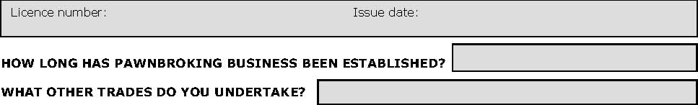
BANK REFERENCE: TRADE REFERENCE:
DECLARATION
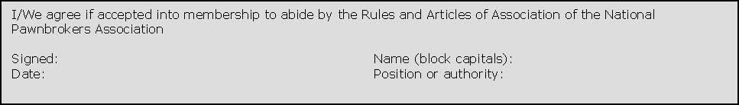
PLEASE ENCLOSE COPIES OF THE FOLLOWING DOCUMENTS WITH YOUR APPLICATION: CONSUMER CREDIT LICENCE

